***Project Name – The Daily Reporter***

***Group 10***

*Aisha Mahmood – 217714189*

*Harshil Kumar – 218198978*

*Esha Vij – 2181823307*

*Nishiket Singh - 216521197*

The Daily Reporter Vision Statement

The Daily Reporter will be used to serve the purpose of multiple applications in one for all types of users. This platform will be able to provide the latest weather updates and keep users informed on current affairs around the world. The system is proposed to be a desktop application but with an executable file.

This system is designed to incorporate a multitude of features to be as versatile as possible. It is intended for all users to have the same experience of using the system. Therefore, it will contain a voice-over feature to read out the text for visually impaired users. Since the system will be used around the globe, it will enable users to select the language they are most comfortable with and choose a region for the news and weather updates to be localised.

In this day and age, the public welcomes discussions and expresses their opinions; therefore, a feature was incorporated to allow users to share their points of view on articles. To make the whole experience of using this platform more personalised, users can create an account to be able to subscribe to specific news articles and receive email notifications to stay up to date with the latest news. There is a calendar feature as a helpful tool for keeping track of articles being uploaded.

Keeping in mind that not every user will have the same preference for the articles they read, it provides a space for news to be divided up into categories in which filters can be applied to search for specific genres of information.

Looking at it from the publisher's point of view, we wanted to make their experience effortless. They have access to upload their articles in various file formats and not worry about organising their articles into categories.

The scope of success for this project will be measured by its effectiveness and by taking the client's requirements and implementing all of them to ensure the project brings the expected results. Delivering a quality product within the client's budget and timeline are two factors that our team will work together to achieve. Being able to produce a system that is user-friendly is one of our criteria. That being the case, conducting a test trial to get critical feedback from users so we can adjust and improve where the system is lacking.

***Big User Stories***

***Iteration 1:***

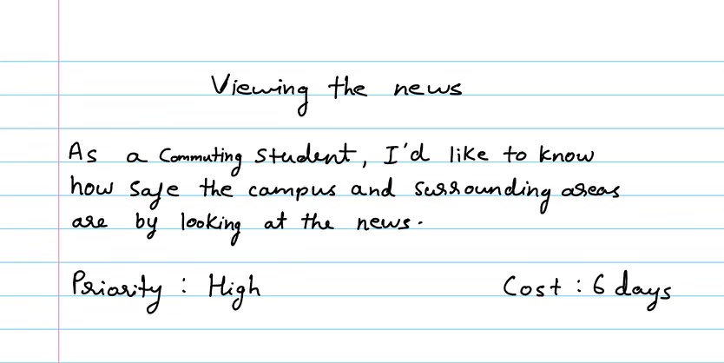

***Iteration 2***

***Iteration 3:***

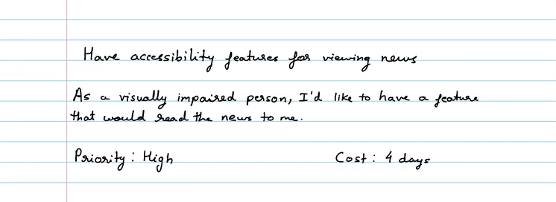

***Detailed Big Stories:***



